**Mapping**

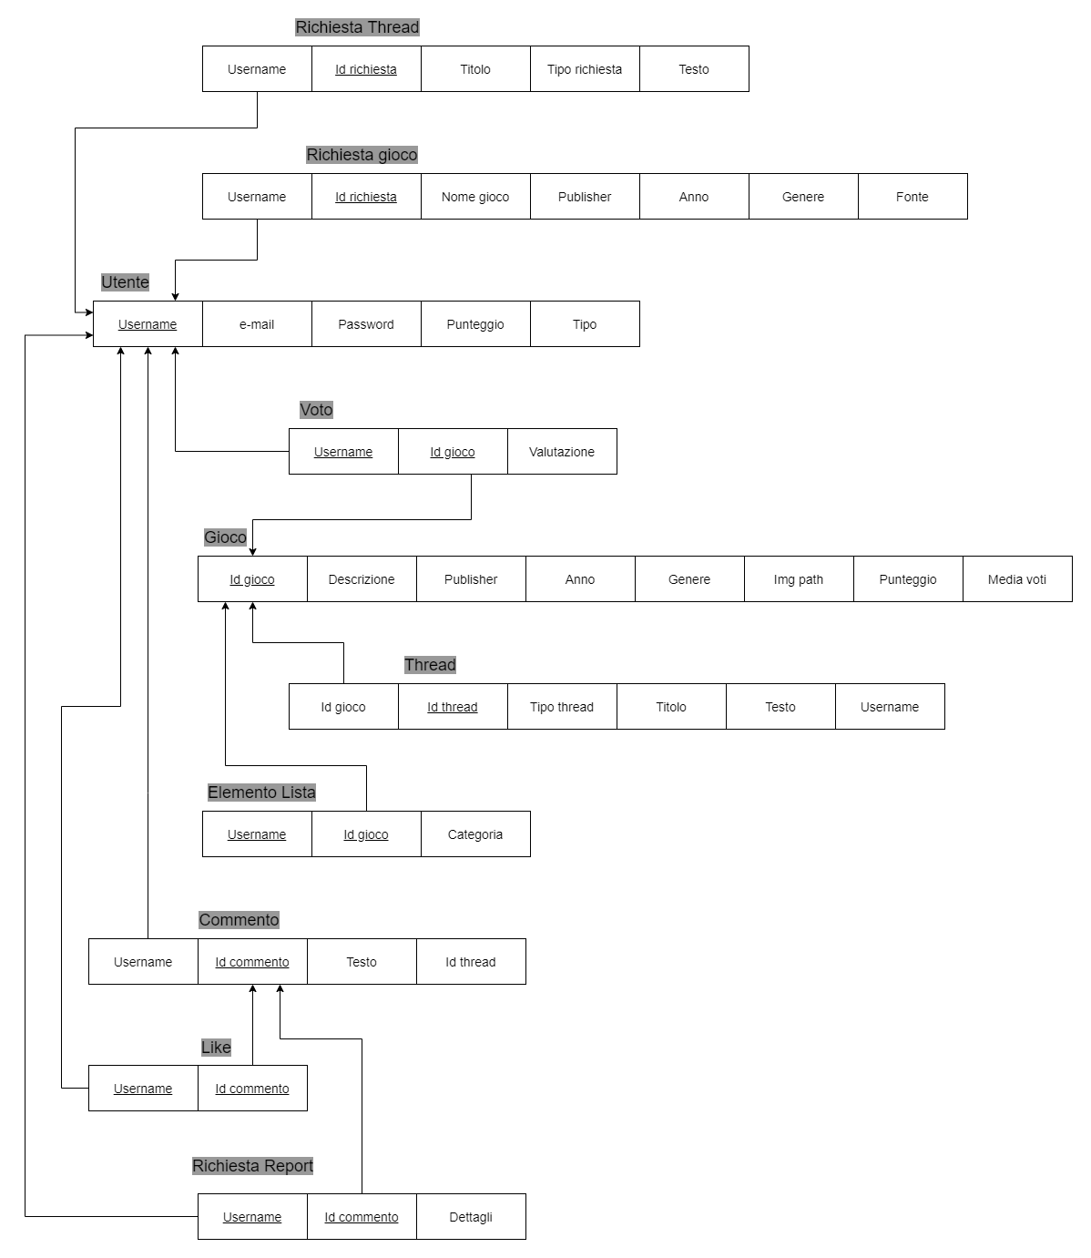

**UTENTE**

|  |  |  |  |
| --- | --- | --- | --- |
| **Attributo** | **Tipo** | **NULL** | **Key** |
| **Username** | Varchar(50) | NOT NULL | Primary Key |
| **e-mail** | Varchar(45) | NOT NULL |  |
| **Password** | Varchar(50) | NOT NULL |  |
| **Punteggio** | Int | NOT NULL |  |
| **Tipo** | Varchar(15) | NOT NULL |  |

**GIOCO**

|  |  |  |  |
| --- | --- | --- | --- |
| **Attributo** | **Tipo** | **NULL** | **Key** |
| **Id gioco** | Int | NOT NULL | Primary Key |
| **Nome** | Varchar(50) | NOT NULL |  |
| **Descrizione** | Text | NOT NULL |  |
| **Publisher** | Varchar(50) | NOT NULL |  |
| **Anno** | Varchar(4) | NOT NULL |  |
| **Genere** | Varchar(30) | NOT NULL |  |
| **Imgpath** | Varchar(50) |  |  |
| **Punteggio** | Int | NOT NULL |  |
| **Media voti** | Float |  |  |

**VOTO**

|  |  |  |  |
| --- | --- | --- | --- |
| **Attributo** | **Tipo** | **NULL** | **Key** |
| **Valutazione** | TinyInt | NOT NULL |  |
| **Utente** | Varchar(50) | NOT NULL | Foreign Key  Primary Key |
| **Id gioco** | Int | NOT NULL | Foreign Key  Primary Key |

**THREAD**

|  |  |  |  |
| --- | --- | --- | --- |
| **Attributo** | **Tipo** | **NULL** | **Key** |
| **Id thread** | Int | NOT NULL | Primary Key |
| **Tipo thread** | Varchar(50) | NOT NULL |  |
| **Titolo** | Varchar(50) | NOT NULL |  |
| **Testo** | Text | NOT NULL |  |
| **Utente** | Varchar(50) | NOT NULL | Foreign Key |
| **Id gioco** | Int | NOT NULL | Foreign Key |

**RICHIESTA GIOCO**

|  |  |  |  |
| --- | --- | --- | --- |
| **Attributo** | **Tipo** | **NULL** | **Key** |
| **Id Richiesta** | Int | NOT NULL | Primary Key |
| **Utente** | Varchar(50) | NOT NULL | Foreign Key |
| **Nome gioco** | Varchar(50) | NOT NULL |  |
| **Publisher** | Varchar(50) | NOT NULL |  |
| **Anno** | Varchar(4) | NOT NULL |  |
| **Genere** | Varchar(30) | NOT NULL |  |
| **Fonte** | Text | NOT NULL |  |

**ELEMENTO LISTA**

|  |  |  |  |
| --- | --- | --- | --- |
| **Attributo** | **Tipo** | **NULL** | **Key** |
| **Utente** | Varchar(50) | NOT NULL | Foreign Key  Primary Key |
| **Id gioco** | Int | NOT NULL | Foreign Key  Primary Key |
| **Categoria** | Varchar(50) | NOT NULL |  |

**RICHIESTA THREAD**

|  |  |  |  |
| --- | --- | --- | --- |
| **Attributo** | **Tipo** | **NULL** | **Key** |
| **Id Richiesta** | Int | NOT NULL | Primary Key |
| **Utente** | Varchar(50) | NOT NULL | Foreign Key |
| **Titolo** | Varchar(50) | NOT NULL |  |
| **Tipo** | Varchar(20) | NOT NULL |  |
| **Testo** | Text | NOT NULL |  |

**COMMENTO**

|  |  |  |  |
| --- | --- | --- | --- |
| **Attributo** | **Tipo** | **NULL** | **Key** |
| **Id commento** | Int | NOT NULL | Primary Key |
| **Id thread** | Int | NOT NULL | Foreign Key |
| **Testo** | Text | NOT NULL |  |
| **Utente** | Varchar(50) | NOT NULL | Foreign Key |

**LIKE**

|  |  |  |  |
| --- | --- | --- | --- |
| **Attributo** | **Tipo** | **NULL** | **Key** |
| **Utente** | Varchar(50) | NOT NULL | Foreign Key  Primary Key |
| **Id commento** | Int | NOT NULL | Primary Key  Foreign Key |

**RICHIESTA REPORT**

|  |  |  |  |
| --- | --- | --- | --- |
| **Attributo** | **Tipo** | **NULL** | **Key** |
| **Utente** | Varchar(50) | NOT NULL | Foreign Key  Primary Key |
| **Id commento** | Int | NOT NULL | Primary Key  Foreign Key |
| **Dettagli** | Vatchar(200) |  |  |